Assessment Number: AS 91901 Digital Technologies

Internal: 3 Credits Level 3

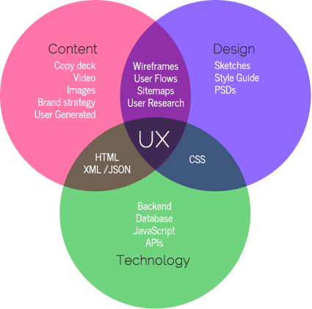

Apply user experience methodologies to develop a design for a digital technologies’ outcome

Contents

Stakeholder Questions 4

Brief and Specs 5

Brief 5

Target Audience 5

Specs 5

Layout 5

Investigating UX Methodologies 6

Card Sorting 6

User Persona 6

Competitive Analysis 6

Applying UX Methodologies 7

Competitive Analysis 7

User Persona’s 8

Card Sort 9

Similarity Matrix 9

Dendrogram 9

3D Cluster 9

Site Map 10

Gut Test 11

Analysis 11

Wireframes 12

Why we use them 12

Final Wire Frame Design 15

Usability Testing 16

High Fidelity 17

Final High-Fidelity Design 21

Evaluation 22

Final Justifications 23

UX Methodologies 23

Purpose and End Users 24

Relevant Implications 24

Accessibility 24

Legal 25

Aesthetics 25

Social 26

End User Considerations 27

# Stakeholder Questions

* **What is your role in this project?**

I won this upcoming company and I’m just here to make sure everything runs smoothly and if it is what I imagine.

* **What is this project going to be?**

I would like an app that trading companies can use to find delivery services that they can use during lockdown, for safe contactless deliveries, so business can continue.

* **Who is this product for?**

Trading Companies and Delivery Drivers

* **What should this project accomplish for your business? What is your goal?**

It will allow us to safely continue operating during lockdown

* **Who are your biggest competitors and what worries you about them?**

Courier and NZ Post.

* **How would you like people to see your brand?**

As a friendly, reliable source of delivery company, where they can form bonds and be a safe place for everyone

* **What problem does your product solve?**

It allows those who have los their job during covid-19 to have a new position in a trusted company, where work is almost guaranteed, and allows trading companies to continue safety during lockdowns.

* **What is the accessibility of the product?**

It will be available on IOS and Play store, so everyone can use it

* **Are there any products you would like to use as references?**

Uber Eats and Rendre

* **Are you in need of a domain name or is one already created?**

A domain name and logo are already provided

* **How often will users use your product?**

As often as they need. Its not a main source of income for me, but rather just a way in case users need it.

* **Do you have a deadline for completion of this project?**

Not a specific deadline, but preferably before the end of this year

* **How many users are you expecting to use your product?**

Initially once the app is released around 50, but hopefully many more when it becomes more known and trusted.

# Brief and Specs

## Brief

TradesFleet is an upcoming company run and designed by Martin Hunt. Martin works for JSC timbers currently, and with his recent experience with covid-19 and how it affected the company he works for, he was inspired to create a way for trading companies and those who were sadly stood down due to covid-19 , an easy opportunity for money. TradesFleet is a delivery-based app where you can order a driver to safely and contactless if needed transport packages to their destination. This also works as a cheaper option for some bigger company delivery services like UberEATS or couriers NZ. It also allows for you to in up to become a driver, where you earn based on size of package, distance and time.

## Target Audience

TradesFleet is aimed at trading companies that may not have their own delivery services for customers or other companies. It also is targeted at those who need a job and are reliable enough to be trusted with other people’s packages.

## Specs

Navigation

Home

About Us

Fees

Leave us Feedback

Become a driver

Our drivers

Find a driver

Map

Account

Create an Account

## Layout

Logo provided

Use the logo colour as main theme through site.

Imagery provided to break through text

To the point, concise, no need for a lot of words.

Easy navigation

# Investigating UX Methodologies

## Card Sorting

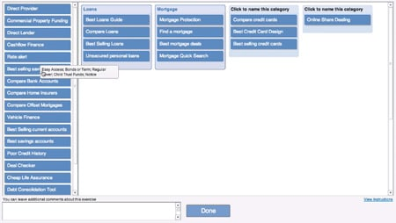Card sorting is a method used to help evaluate and design information. Participants organise topics into categories that make them make sense to themselves and group them accordingly. There are many different software tools and methods to do a card sort. Once the data is collected its is then analysed to identify common trends; this can be done through using a cluster analyse for smaller portions of data. Card sorting helps to find out some functional information about users.

## User Persona

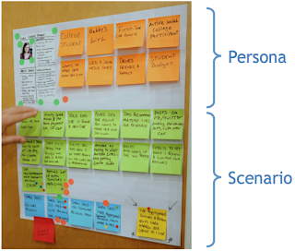User personas are fictional characters which you create based upon research in order to represent the different user types that might use the product or service you are creating. They help you understand your users' needs, experiences, behaviours and goals. User Persona also helps you recognise different needs and expectations for possible clients. It helps makes the task less complex and help guide your ideation process. Personas do not describe real people, but you can compose your personas based in real data collected from multiple individuals. They add a real touch to what would usually be largely cold facts in your research. It also assists in understanding patterns in research which synthesises the types of people you wish to design for. They provide meaningful architypes which you can use to access your design development against. It helps you ask the right questions and answer those questions in line with the users you are designing for. There are 4 different perspectives on personas - goal directed personas, role-based personas, engaging personas and fictional personas

## Competitive Analysis

Competitive Analysis is a part of the design process to help business gain valuable insight into the market, identify the strengths and weaknesses of their products, and develop effective product strategies to create winning results. It involves researching and assessing your competition. You then

asses where your product or design stand in the market and define any gaps in the market.

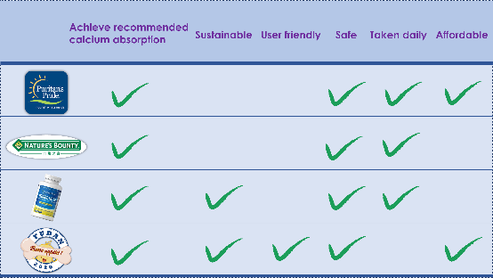It is important to research and find out the strengths and weaknesses of your competition. You then identify the advantages and disadvantages of your products and have evidence to back up your design changes. Competitive analysis helps you solve usability issues and enables you to develop your go-to-market strategy. Competitive analysis is one of the earliest steps in the research phase of a UX design process. It assists in the outline your goals and define your process. You need to compile a list of your direct and indirect competition (indirect is companies that offer the same products at a similar price points to satisfy customer's needs)(Indirect is companies that offer different products or services in the same market that can potentially satisfy the same need), and then create a comparison chart based of the competitors product features. Then you identify the differences between products and summarize and present your findings. It helps to use the SWOT planning method (Strengths + weaknesses + opportunities + threats).

# Applying UX Methodologies

## Competitive Analysis

Through using the competitive analysis methodology, I can see what my competitive have, that I should include in order to satisfy the market and my possible future users. I have used 4 different delivery service apps and websites, render, FedEx, UberEATS and NZ Courier. I have tested them on most common and best helpful features to see what I am competing with. By comparing the different features, I have reduced the amount of time and research during the actual development stage, so that I can clearly see what I should and shouldn’t include in my own app. It also offers an opportunity for me to not only see my competitor’s strengths and the things they do well, I can also see what their weaknesses are and try to avoid having them myself.

The feature common across all four apps is the tracking feature, so this clearly indicates that this could be a feature that users look for in their delivery apps. Rendre and Uber Eats also have a delivery choice time, which allows the users to book a driver well in advance if needed, so this could be a feature we include in our delivery app. Only FedEx provide a HelpBot for their users, and considering a wide range of age groups and technical capabilities of our possible future users, this could be a gap we can fill within our own app. Uber Eats is close to what our app intends to achieve, although they only deliver food, so the are not a huge competitor. FedEx and Courier are more commercial delivery services, where we are hoping to achieve a more personal, friendly deliver opportunity between our trades. Rendre, after some research is basically on the same path as us, although they are not available in NZ, so currently we have no competition with them.

|  |  |  |  |  |  |  |  |
| --- | --- | --- | --- | --- | --- | --- | --- |
| **Features** | **Rendre** | **FedEx** | | | **Uber Eats** | | **NZ Courier** |
| **Available in NZ** |  |  | | |  | |  |
| **Tracking Feature** |  |  | | |  | |  |
| **Information on driver available** |  |  | | |  | |  |
| **Delivery Time choice** |  |  | | |  | |  |
| **Help Bot** |  |  | | |  | |  |
| **Available on App and Website** |  | |  |  | |  | |

## User Persona’s

User Personas are prototypical users whose goals represent and display the needs and requirements for a larger group of users. They usually display the characteristics, skills, attitudes, and biography that the personas work in. Designers tend to make fictional persona details to make a realistic character. This allows for a deeper understanding of who the target audience is, which overall leads to a better product. By understanding the goals, frustrations, and motivations of possible target audiences, it helps to design and create a product and outcome that satisfies and meets the needs for your target audience. As you can see on the previous page, I have created 2 user personas, which describe two different personalities, but who overall desire the same thing. With a common ground of wanting to continue work through the tough times of covid-19 lockdown, they both want a way to accomplish it effectively and safely. Vicki wants to be able to keep her clients and give them what they want and need in a safe manor, while Daniel wants to be able to pay all his employees their full pay-check through lock down. By analysing these personas, it helps me, and my client devise a plan that will meet the needs of both personas. This will be done through an app that allows trading companies to deliver and get materials from one another contactless, through reputable and trusted drivers, whilst also offering job opportunities as a driver.

## Card Sort

I have used the programme optimal workshop to test and gather a range of results for the different categories and section for my navigation, to see based on common answers what navigation would be the most appropriate and make the most sense. I had my card sort completed by 5 people, which allows for some diversity in answers. More participants would be ideal, but I am working with what I have available.

### Similarity Matrix

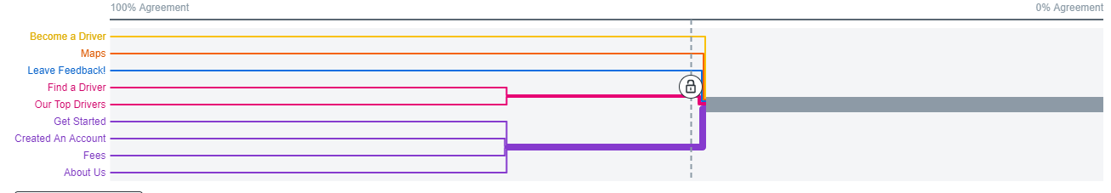The similarity Matrix is a visual diagram of the responses I gathered through the site optimal workshop. The numbers represent the percentage of responses that other responses put together in the same group. The darker the shade of blue, the more often and consistently they are grouped together. Based on my similarity matrix result, we can see that the titles with the most consistent results are Get Started and Create an Account, Create and Account and Fees, Our Top Drivers and Find a Driver and Get Started and About Us. By having this Matrix, it allows me to then create a site map and navigation layout that I know based and these results will make the most sense to my possible users.

### Dendrogram

The Dendrogram is a way to show how many responses categorised what field into what groups. It shows the percentage of those results which are most commonly paired or grouped together. It helps to easily differentiate between the different categories and labels. This visual representation is just another way for me to see the results. It confirms and shows a different aspect of how my users came to the conclusion of that card sort. Having different representations of the results allow me to fully understand and come to rational, thought about conclusions as to how my sitemap and navigation will be.

### 3D Cluster

The three-dimensional cluster view visualises card similarity as three-dimensional spatial relationships. A single card is represented by each point in the graphic. Cards that were closer together were categorised into the same category more frequently. Polygons are displayed over clumped-together sets of cards. Each of these groups can be viewed as a possible category within a larger category.

# Site Map

From the results gathered for my cord sort, I have made a site map that visually represents the page layouts of the app. I have 3 main pages of the navigation, which as you can see above, is About us, Drivers and Account. These 3 pages each have subpages that correlate with them. The about Us page has the subpages Fees and Leave feedback. The drivers page has the subpages of Become a driver, find a driver, maps, and our top drivers. The account page has the subpages of Create an account and Edit your account. Having a sitemap allows me to see what content my client wants, and how I can logically split it in a way that makes sense, not only to me and my client, but to possible future users. From this site map, I can then start to design my first wireframe with the associated pages.

# Gut Test

[Gut Test](https://longbaycollege-my.sharepoint.com/:p:/g/personal/17355_lbc_school_nz/Ebu_Erv8vyNFo8wZGQZDRlYBFcdwMSLciJAXAgH1QbEiYg?e=dq2lVG)

(feedback in the comments section)

## Analysis

Based on the feedback gotten for my gut test, it has assisted me in coming to conclusions regarding my aesthetics and layout of my app. I now know it is important to have my navigation bar and search bar at the top of the pages for **consistency and standards**. The navigation bar, help bot, search bar and logo are all found in the place where you would expect it to be. There is no confusion and wording, or placement and the user doesn’t have to go looking for anything. It is also important in the search bar to include the icon of a magnifying glass. This is also an example of **match between system and real world**, as they have a magnifying glass, indicating search. This is internationally understood and used as people see that icon as to ‘look for’ or ‘search’ which is that buttons exact purpose. The importance of a main theme colour throughout the app adds **aesthetically** to the app as emphasis colour, while also helping with **consistency and standards.** I must also ensurethe **font** is easy to read and has good **emphasis** on outstanding words. The use of **straight lines** throughout the site is also good as it gives of a modern, slick, and professional look. I will make sure everything aligned correctly, and the app has **flow** and **repetition**. After comparing the different apps in the gut test, I have found the importance of majority of the content being in black and white but also using complimenting colours to make it stand out more. The use of **white space** is also important as it gives the eye a break and makes the website lean, eye catching but not bombarding or crazy. There will be nice **flow** and **consistency** throughout the app and will allow the user to enjoy their time visiting the app rather than throwing things in their face. **Placement** and **alignment** are also important to keep consistent, as a professional app, and will assist in leaving our users feeling secure and safe that they are using a trusted company.

# Wireframes

## Why we use them

Wireframes are the blueprint of web design. They show not only the allocation of the different elements within the app, but also how the app will flow and how the pages correlate with one another. Wireframes also help to understand your client ideas and goals. The feedback you get from the client, as well as just conversation regarding the app will help you not only achieve what they desire sooner, and get you on the same page, but also help later on in the project, as you will begin to understand how they think and where their attention and focus lies.

|  |  |
| --- | --- |
| **V 1** | **Feedback** |
|  |  |
|  | I like the simplicity of the logo. Perhaps adding more colour/brighter colours might attract more users to the app. |
|  | The welcoming to the app is a good idea. Maybe you could add a login function to this page for users to access their account when they first open the app. In terms of the layout, you could extend the search bar to remove the awkward gap in the header. |
|  | I like the visual aspect of the page as it breaks up the large amount of writing on it that can deter users away from the page. |
|  | I enjoy the layout of this page, and I really like the simplicity of it. |
|  | Not sure what else to add to the page, but its quite boring. Perhaps in the final design a colourful background (maybe matching the logo colours) could add something to the page. |
|  | The layout of the page so far is good. You could add more below such as reviews for the user to see on their account. |
| **V2** | **Feedback** |
|  | I prefer the original (White) over the black as the user can clearly see the company colours and slogan more visibly. The black is also too harsh and not as inviting as the white, as the wite offers a sense of purity, softness, and openness. The use of white space behind the logo makes the black outlined logo stand out as well as having a bold font for the actual name of your company then its slogan in smaller text making it less important but still there. |

## Final Wire Frame Design

|  |  |
| --- | --- |
|  |  |
|  |  |
|  |  |

# Usability Testing

Usability Testing allows me to see if my design and layout of my app is easy to navigate and understand. I have tested this by giving my client 3 different tasks, and attempt to navigate his way through the app and achieve them. I have made my wireframes through proto.io, and have made them interactive so it mimics the actual functionality of the final app. Any changes that I am required to make will be shown through the high fidelity.

1. Edit your account details

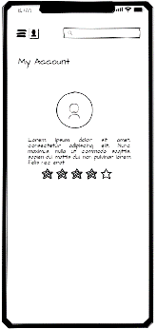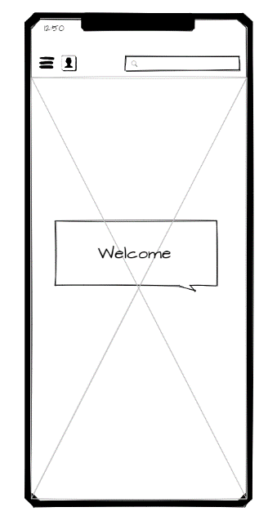

Clicked on the profile icon. Selected account.

Under my account page I could not find a place to edit the information already put in there. When you are in the account page there should be a way for the users to change or update their information, and for it to be easily accessible.

1. Find out how much is would cost if you wanted to book a medium sized parcel delivery

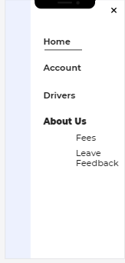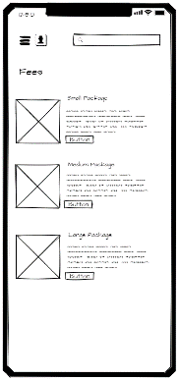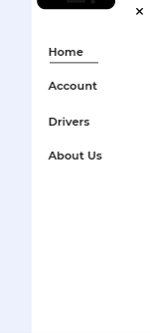

Clicked on the drop down in heading, selected about us and then the subpage fees. Found the prices based on package size. This one was self-explanatory and didn’t take long to figure out.

1. Make a complaint 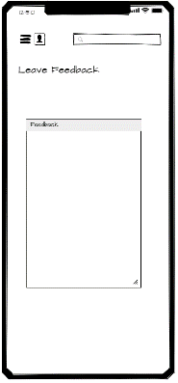

This was easy enough to find, its just once you type your feedback, how do u submit it?

# High Fidelity

|  |  |
| --- | --- |
| **V1** | **Feedback** |
|  |  |
|  | After viewing the original welcome page as a high fidelity, I have decided it is way too boring, unprofessional, and just overall lacks personality. I asked Jordan to design a new page, like one from the gut test, with more colour and visuals so that it seems more inviting. |
|  | I really like this page, It is bright, colourful and modern. It currently looks cramped but I am aware that the page will be scrollable so it can be more spaced out on the actual outcome. |
|  | This page is good, I like how there is a contrast of the different shades of blue, and it also adds some excitement and freshness. |
|  | This Is good. If you could just make sure everything is perfectly aligned that would be great. I also love the addition of the contact page; it definitely adds something that the page was missing. |
|  | Looks good, maybe move the writing to before the update account button, or just fully delete it, I’m not sure what its purpose was |

|  |  |
| --- | --- |
| V2 | Feedback |
|  | This is much better, perfect ☺ |
|  | Looks much better, also allows room for future development |

|  |  |
| --- | --- |
|  |  |
|  |  |
|  |  |

## Final High-Fidelity Design

# Evaluation

After finishing this planning report, I have had the opportunity to sit down and go through all decisions and stages made throughout the process of designing this app. I have worked constantly alongside my client, making sure all decisions had his input, and together we have created a fun, interactive and accessible app that offers job opportunities as well as promoting and assisting work continuing through lockdowns. This has been a very smooth process and there were not any hiccups, drastic changes, or issues in terms of just the project, that slowed down the continuation, so everything went according to plan. My client is very happy and satisfied with the final outcome design of his app and looks forward to seeing it come to life. If we had more time, we would have liked to include more pages in the app. He would have also liked a blog feature in the site, where he can enter daily or weekly entries on how this project is doing, so that the users feel closer and more understanding of Martin and his goals. I would’ve liked to work more on the high fidelity and wireframes, as I didn’t get an opportunity to design every page in the app. I believe these are all creative additions and would like to in the future work with my client again to update the app and improve it as much as possible to achieve all of his desires.

# Final Justifications

## UX Methodologies

By using the UX methods above, it has given me and my client an opportunity to design a product that is relevant, useful, easy and one that offers a pleasurable user experience. It also offers us the ability to find out which feature we need to prioritize and focus more on, overall giving as clarity and insight around this project.

Through the use of User personas, we were able to line up the goals of our users, to the goals of our product. If a user’s goal is met, then they will have a pleasurable time using the app and will likely return to use it again. By forming that relationship with the users, it also gives an opportunity for that user to recommend the app to friends and colleagues, branching out product out further.

It is also important that in the early stages of designing our product, we were fully aware and accepting of constraints we may have, as well as our competitor’s constraints and weaknesses. This was done through competitive analysis, where we compared 4 different delivery service companies and researched which features, they had and did not have. By doing this is showed my client and I what users were looking for in a delivery app and from there we could go forward to plan and design features that would be important for us to include to promote our product.

Another important aspect we needed to consider was trying the reduce the learning curve of our app by making it easy to use and learn. We created a Card sort through the site ‘optimal workshop’, where we had out heading and titles for the navigation and pages, we wanted to include in our app. We got 5 different people to put each page into a category where they saw best fit. There weren’t any right or wrong answers, just basing it of what made sense to them. After that test we used 3 different visual graphing tools, similarity matrix, dendrogram and 3D cluster, to come to a logical conclusion to what our navigation would be. By using this method, we were able to take into consideration other users quickly and efficiently and how they look at things, rather than the wat we want it.

Wire frames offer a way to visibly show the architecture and layout of the flow between the different pages, whilst allowing for a creative side for where and how you want your content displayed. It also allows me to prioritize different content by making different decisions on thew space you allocate to different sections, whilst offering clarity on the intended functionality of the app itself.

High-fidelity is important because it allows clients to view their product in a branded setting and helps us to test user experience, functionality, and interactivity. The plan is low fidelity, while the final document is high fidelity. Users often mistake high-fidelity prototypes for “live” applications. This means that test participants will be more likely to act realistically, as if they were engaging with a real system, rather than having ambiguous expectations about what is intended to work and what isn't with a rough prototype.

## Purpose and End Users

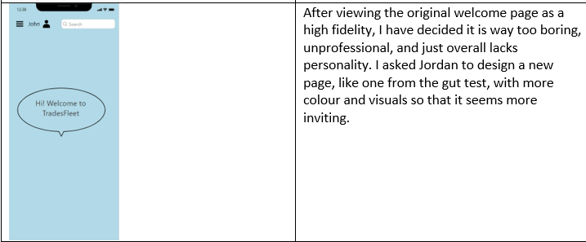The purpose of this app was what brought me and my client together in the very early stages of the design. My client, Martin, works for a timber trading company, where he personally experienced through covid-19 lockdowns, the degradation of work opportunities, pay, and in some extreme, but sadly common circumstances redundancy. After come research and finding out how successful delivery companies such as the Uber franchise, especially food delivery companies over lockdown, we saw an opportunity we couldn’t miss. We wanted to design and create an app that not only allowed trading companies and other business to continue buying and selling their products throughout the covid-19 lockdown, but also provide an opportunity for people to find work when they are struggling. Throughout the time spent designing this app, I have made to sure regularly check back in with my brief and specs given to me by my client to ensure my design is appropriate and meets his needs. My client’s goal was to create an app where through the hard times of covid-19, leaving many people without sufficient funds to live their lives as they usually would, and in some cases even oose their job, people had a last option and, in some cases, where they were not at their last option yet and just needed to continue trading through lockdown and do so safely and contactless. I have collaborated with my client in regards with the design elements of the app, but most of the fundamental content was designed by me. Through each step in the design process, I have got my clients feedback, and have made iterations as suits, so we can not only come to a final design that my client likes, but also one that meets the purpose of this project and can successfully offer an opportunity in the community. One of the phases of design where my client’s feedback was even more valuable, was the high-fidelity stage. It was important to get the high fidelity done as perfect as possible, as it was the closets the client was going to see the app come to life before the actual thing is made. As you can see below, through my clients feedback I was able to build the framing of an app they not only like, but can be proud of.

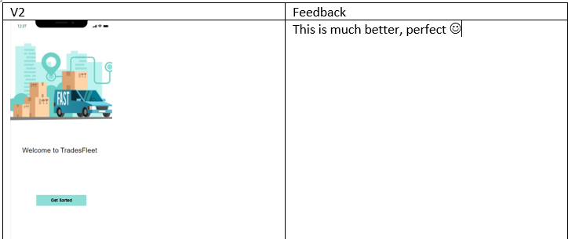

I have made sure the app was easy to navigate, as not everyone using the app will be tech savvy, as it is aimed at tradies and anyone who needs a job, so from any background. I have ensured this through a usability test, where I got my client to complete three tasks, and if there were any issues and confusion, I addressed them immediately. I have made the app bright and upbeat, so it offers a friendly user experience, and gives the opportunity of possibly enticing them to return.

# Relevant Implications

## Accessibility

When creating this app, to meet accessibility requirements, I need to ensure it is usable and suitable for people of all abilities and disabilities. Examples of this could be vision and hearing impairment, dyslexia, and epilepsy. It needs to be well structured and organised and be clear to follow and navigate. I should provide alt texts for images, colours that are easy on the eyes and descriptively named links. It is important to ensure I meet these criteria’s as my users need to be my priority. Having my app be non-accessible means I am not only restricting the number of users I will receive but will have a bed representation of my app and the owner by not catering for everyone’s needs.

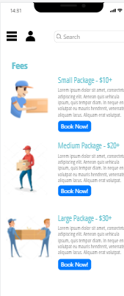I have addressed this by ensuring I use appropriate and proper headings that clearly distinguish the different parts and sections of the app. I have also used different fonts and text sizes to separate different sections of the app. I have also included descriptive alt text for each image and icon, so that the user can get the best idea of what the app layout and navigation works.

All my links have descriptive and self-explanatory names, so that if the user uses a screen reader, they will understand entirely what is going on and can make a good decision on where they want to go. I have selected colours that complement each other in the best way possible. By having 1 main feature colour, it not only adds the feel of similarities between each page on the app, but it also doesn’t clash or compete with the images and icons on the page, and therefore making it a strain on the user’s eyes. I have used black text throughout the site as black is the easiest and clearest colour to read.

I have also used white space to separate the app up and not have too much going on at once. My feature colour is also used to separate sections up so the site is still interesting. I have received feedback from my client as well as potential users and have changed my design to suit their needs and preferences as much as possible to achieve client satisfaction. `

## Legal

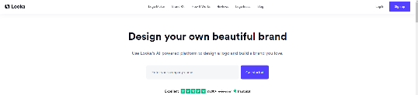When creating this app, to meet legal requirements, I need to ensure that all my digital media (photos, illustrations, videos etc) are not copyrighted and I have full permissions to all of it. To address this, I have made sure that all media I have used within the site is provide to me by the client, and that the client is in full ownership. It is important I meet these criteria’s as not obligating and obeying the legal laws and constraints within the content of my app, is a bad representation of my app and my client’s name. Taking other people’s content and media without permission will not only prove that we do not follow the law but will make us seem like we are an unethical, untrustworthy company which is the opposite of what we stand for.

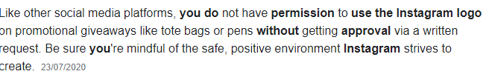To address this, I have made sure that the logo used has been created by my client, Martin Hunt, and is completely original. I have used the logos of Instagram and Gmail within the app, but I have permission to do so from both companies, as I am not using them in a commercial way or for illegal purposes. There are no references and/or screenshots of other companies’ property within the site and all work is completely original.

## Aesthetics

When creating this app, to meet aesthetics requirements, I need to ensure that the site is both simple in appearance and functionality. I need to ensure that the user is satisfied with the site so that they are confident in the dependability of the content within it. It is important to meet these criteria’s as a well put together app that functions well, reassures the users that we ourselves were put together and modern. Having an unprofessional, childish looking app would lead the users to believe that’s what we are, which could result in less users and leaving us looking less reliable.

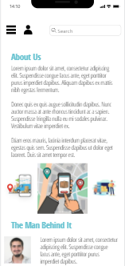To address this, I have made sure that my text is easy to read and follow. This was done by not using similar coloured text and background colour. There is a good contrast between the text and background colours throughout my site, as I have used mainly white background and black text. I have used dark coloured text with light coloured background.

I have made sure to proofread all content within the site to ensure there is no spelling or grammar errors, as this can make my site less reliable and unprofessional. I have ensured that there is a fair use of white space throughout these to make it as easy as possible to follow and not bombard the user with things to look at. This also helps my website look simple, clean, and professional. I have made sure my font is easy to read, modern look and not outdated in anyway.

## Social

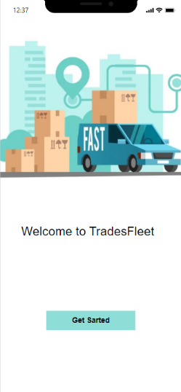When creating this app, to meet social requirements, I need to take into consideration moral aspects. I need to constantly be thinking about the possible users and target audience so I can create a safe, considerate, and respectful site, that doesn’t offend, disturb or prejudice anyone in anyway. This includes body shape, socio economic status, sexuality, gender, culture, and disabilities. It is important to meet these criteria’s as any discrimination, bias, or comments made or displayed in our app would leave us and client with a bad reputation and users would be less inclined to use and give their money to a company that stands for horrible, prejudice things.

I have addressed this by making sure all provided content do not portray anyone or anything in a bad way and that all content is not gruesome or disturbing. There are also no mock-ups of people’s cultures that could be misinterpreted or cause offence by not doing it correctly. I have made sure that I haven’t used any inappropriate language or phrases within my site, to ensure no offense can be taken and is suited for almost all age groups.

## End User Considerations

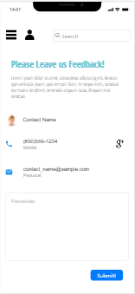When creating this app, to meet end user consideration requirements, I need to make sure my site is completely functional. It needs to be exactly what my client wants and user friendly. It needs to be simple and easy to understand so that most people can use it and understand it. It also needs to be interesting and enjoyable for my client and users to use. It is important to meet these criteria’s as an unfunctional app is just as good as a useless one. We want the app to be user friendly, easy to learn and not confusing, as if a user needs to spend a lot of time trying to figure out how to even use the app, they will be les inclined to return as it becomes to much of a hassle.

I have addressed this by making sure my design keeps the viewer engaged and eager to use the site. It highlights main points of interest within the app. I have made sure navigational aids are visible by having a constant navigation bar throughout my site. This helps the user figure out what he can and can’t do quickly. It also helps the user predicate what their actions will do and helps the user feel confident using the site and have order, consistency, and control.